Worksheet 10.3

Types of intelligence
Student: Class:
Fill in the table below and describe how the type of intelligence relates to you.
Type of intelligence | Description of intelligence | Self reflection
Verbal/Linguistic
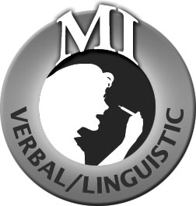
Logical/Mathematical

Bodily/Kinaesthetic

Musical/Rhythmic

Visual/Spatial
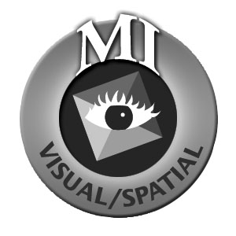
Intrapersonal

Interpersonal

Naturalist


